Huntsville Remote Firetruck Quick Start Guide

**Table of Contents**

Quick Start Guide  3

How to Turn the Firetruck On/Off 3

How to Turn the Controller On/Off 6

Controller Commands 7

How to Fill the Water Reservior 9

How to Charge All of the Batteries 9

Quick Start Troubleshooting  14

**Quick Start Guide**

*Created with the Personal Edition of HelpNDoc:* [*Make Your PDFs More Secure with Encryption and Password Protection*](https://www.helpndoc.com/step-by-step-guides/how-to-generate-an-encrypted-password-protected-pdf-document/)

**How to Turn the Firetruck On/Off**

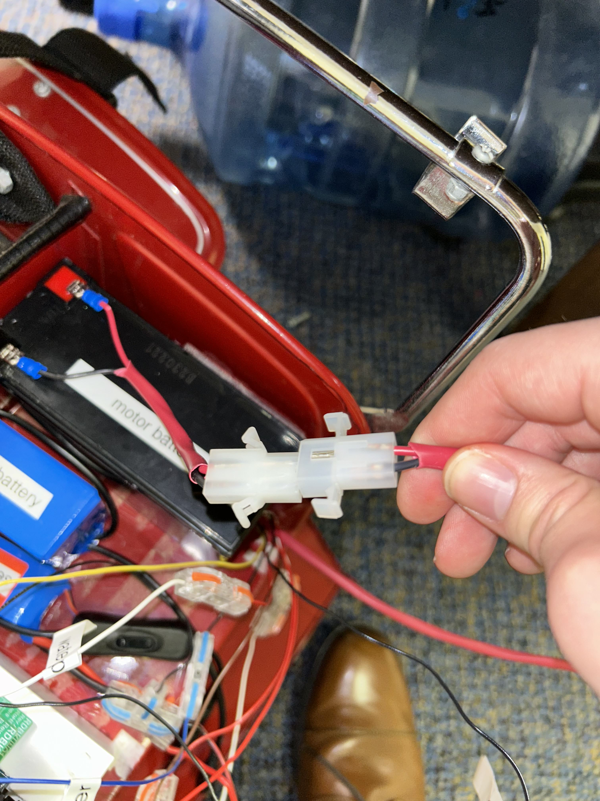

**Steps**:

1. Navigate to the back of the firetruck where the 'trunk' is located

2. Lower the tailgate on the back of the firetruck

3. Upon lowering the tailgate, look for two clips that look like that the ones above in the visual. One clip will be connected to the battery labeled 'motor battery' and the other clip has a thick red cover on it. Once you find the clips, pictured above, click them together

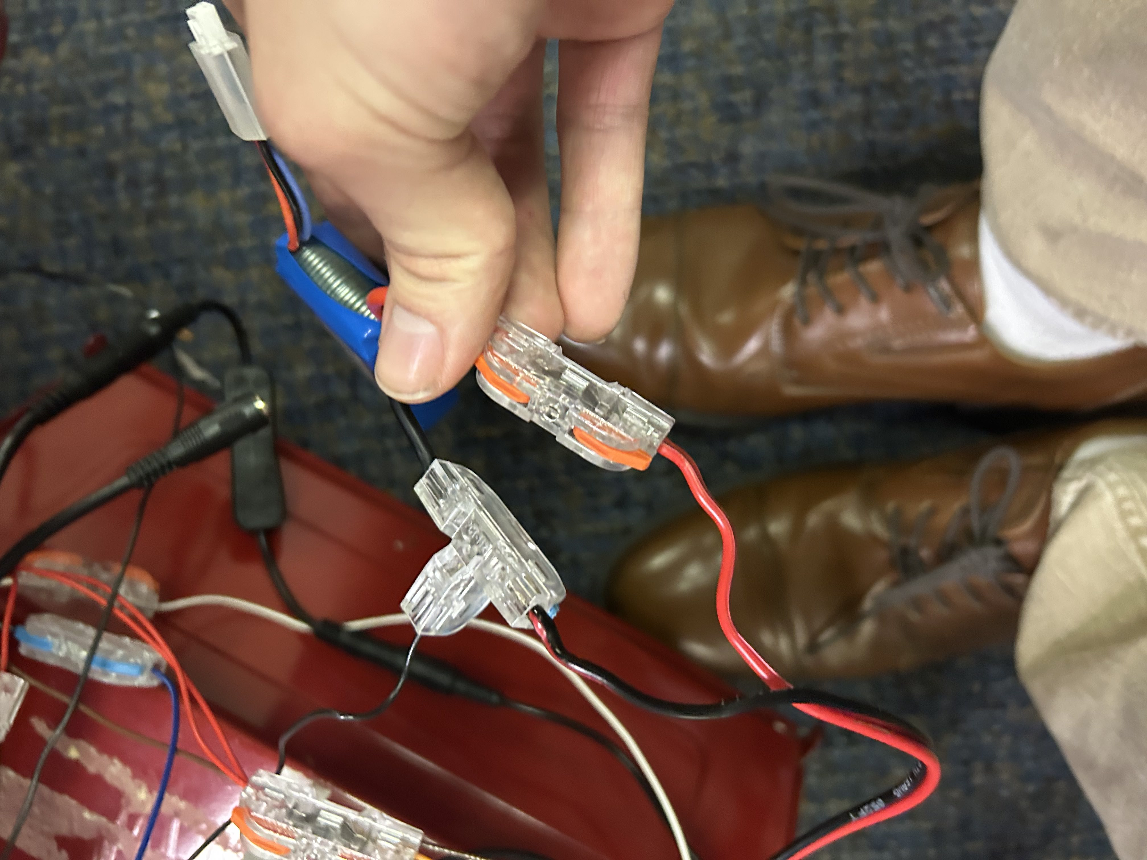

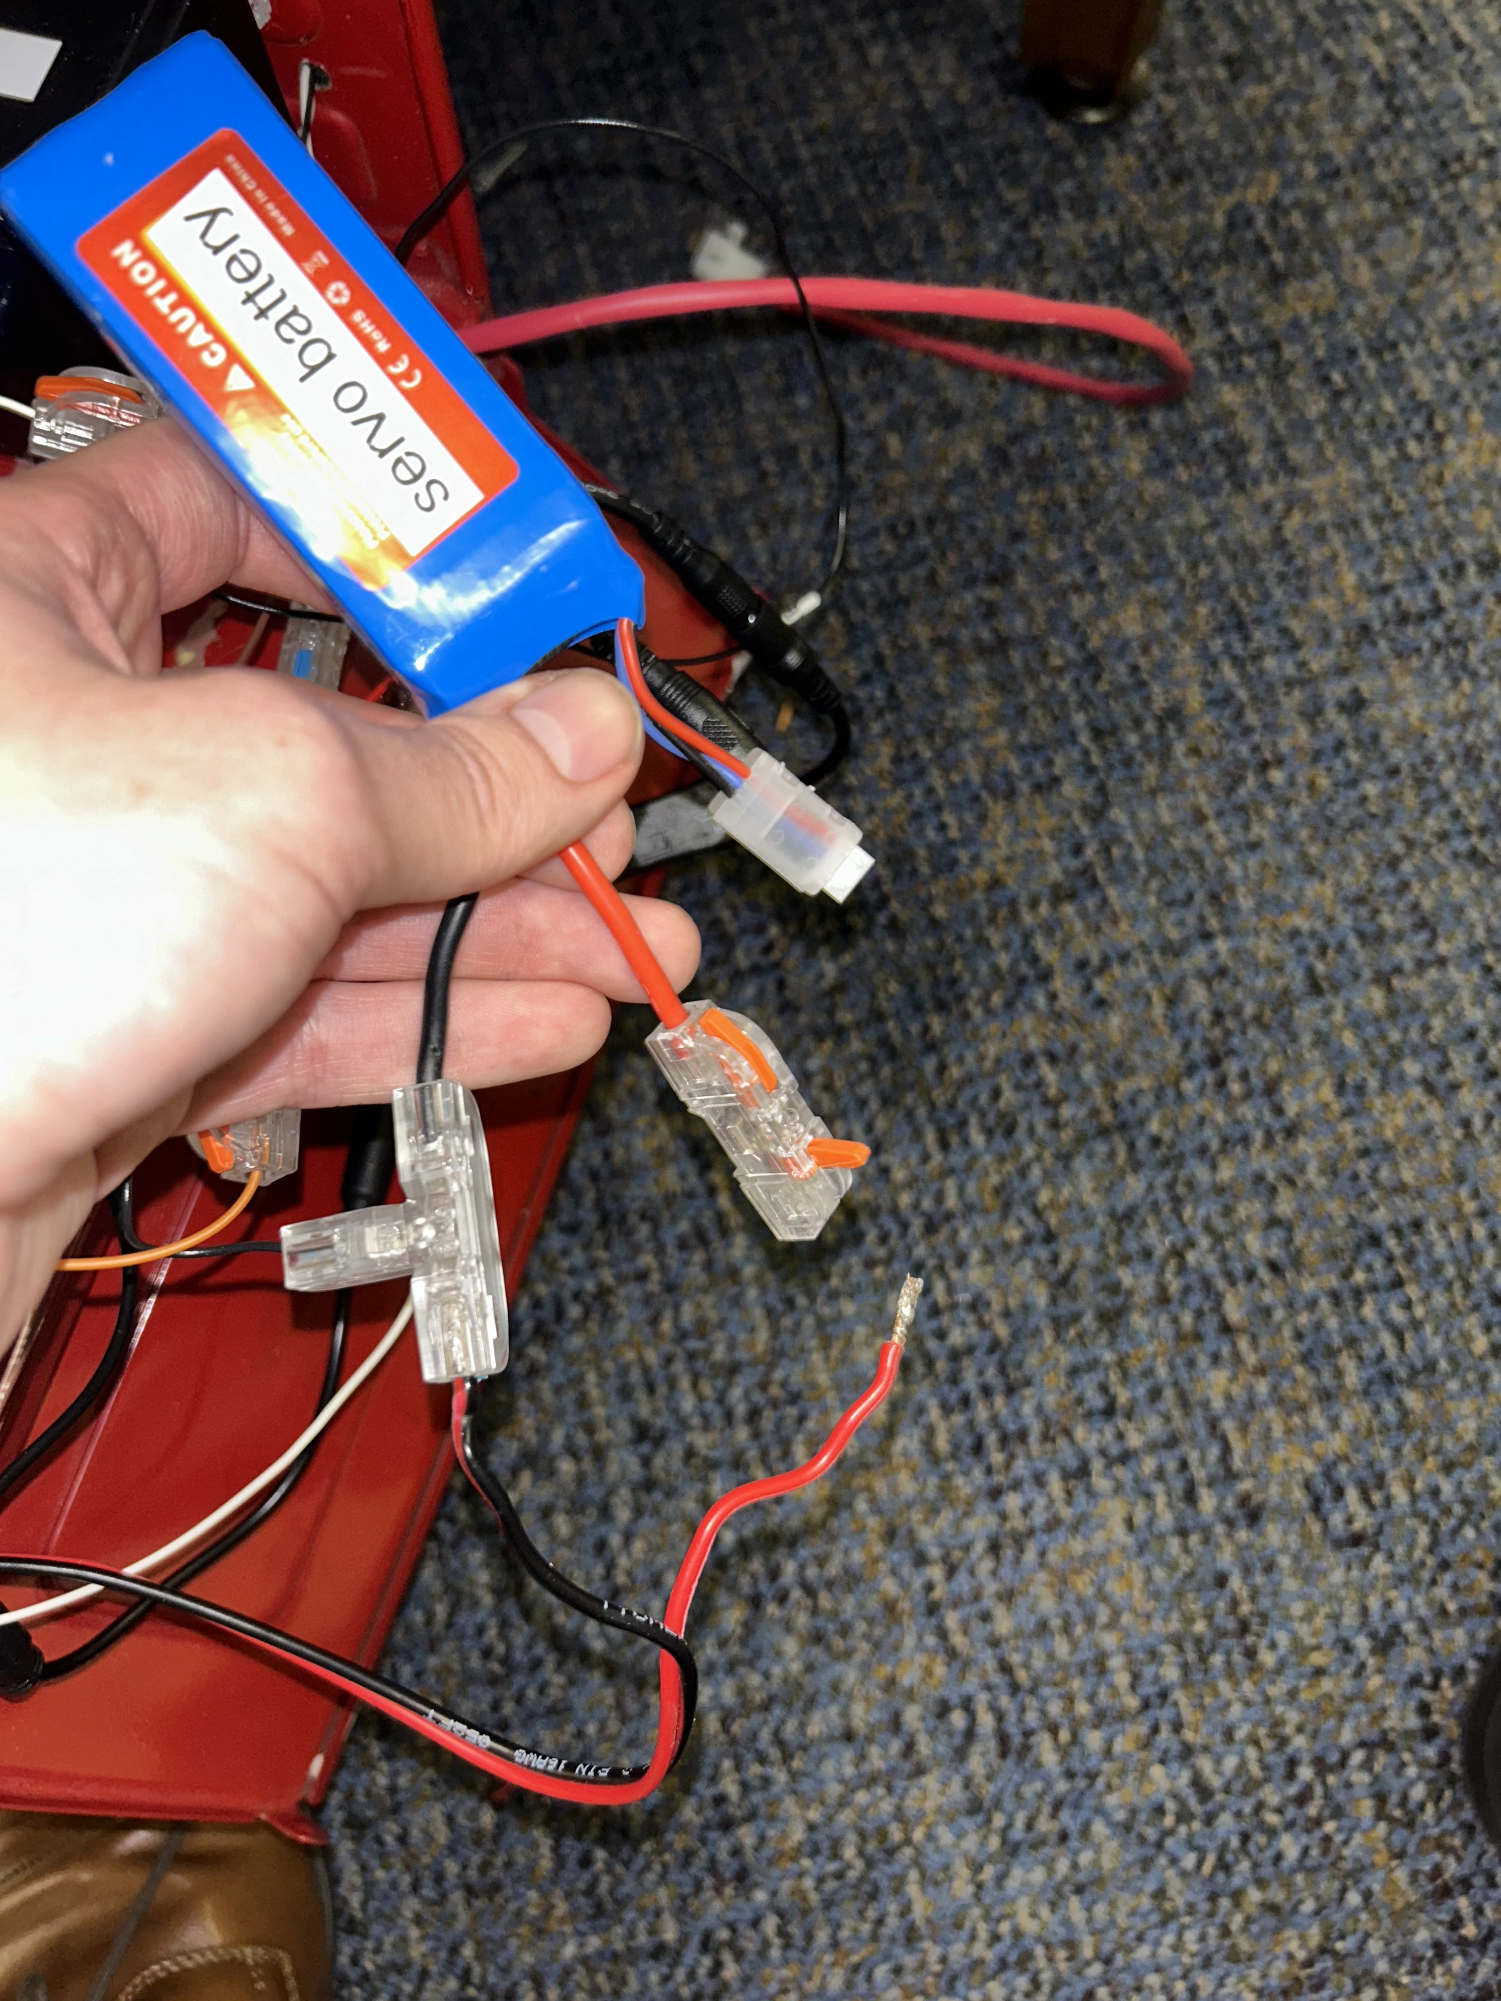

4. After you clip the motor battery together with the motors, look for the battery labeled 'servo battery'

5. Once you find it, look for a loose red wire that looks like one in the above photo and grab it

6. Once you have the red wire, connect it to the plastic connector like in the visual two photos above. You will want to lower the red tab of the plastic connector onto the red wire to ensure a tight secure connection

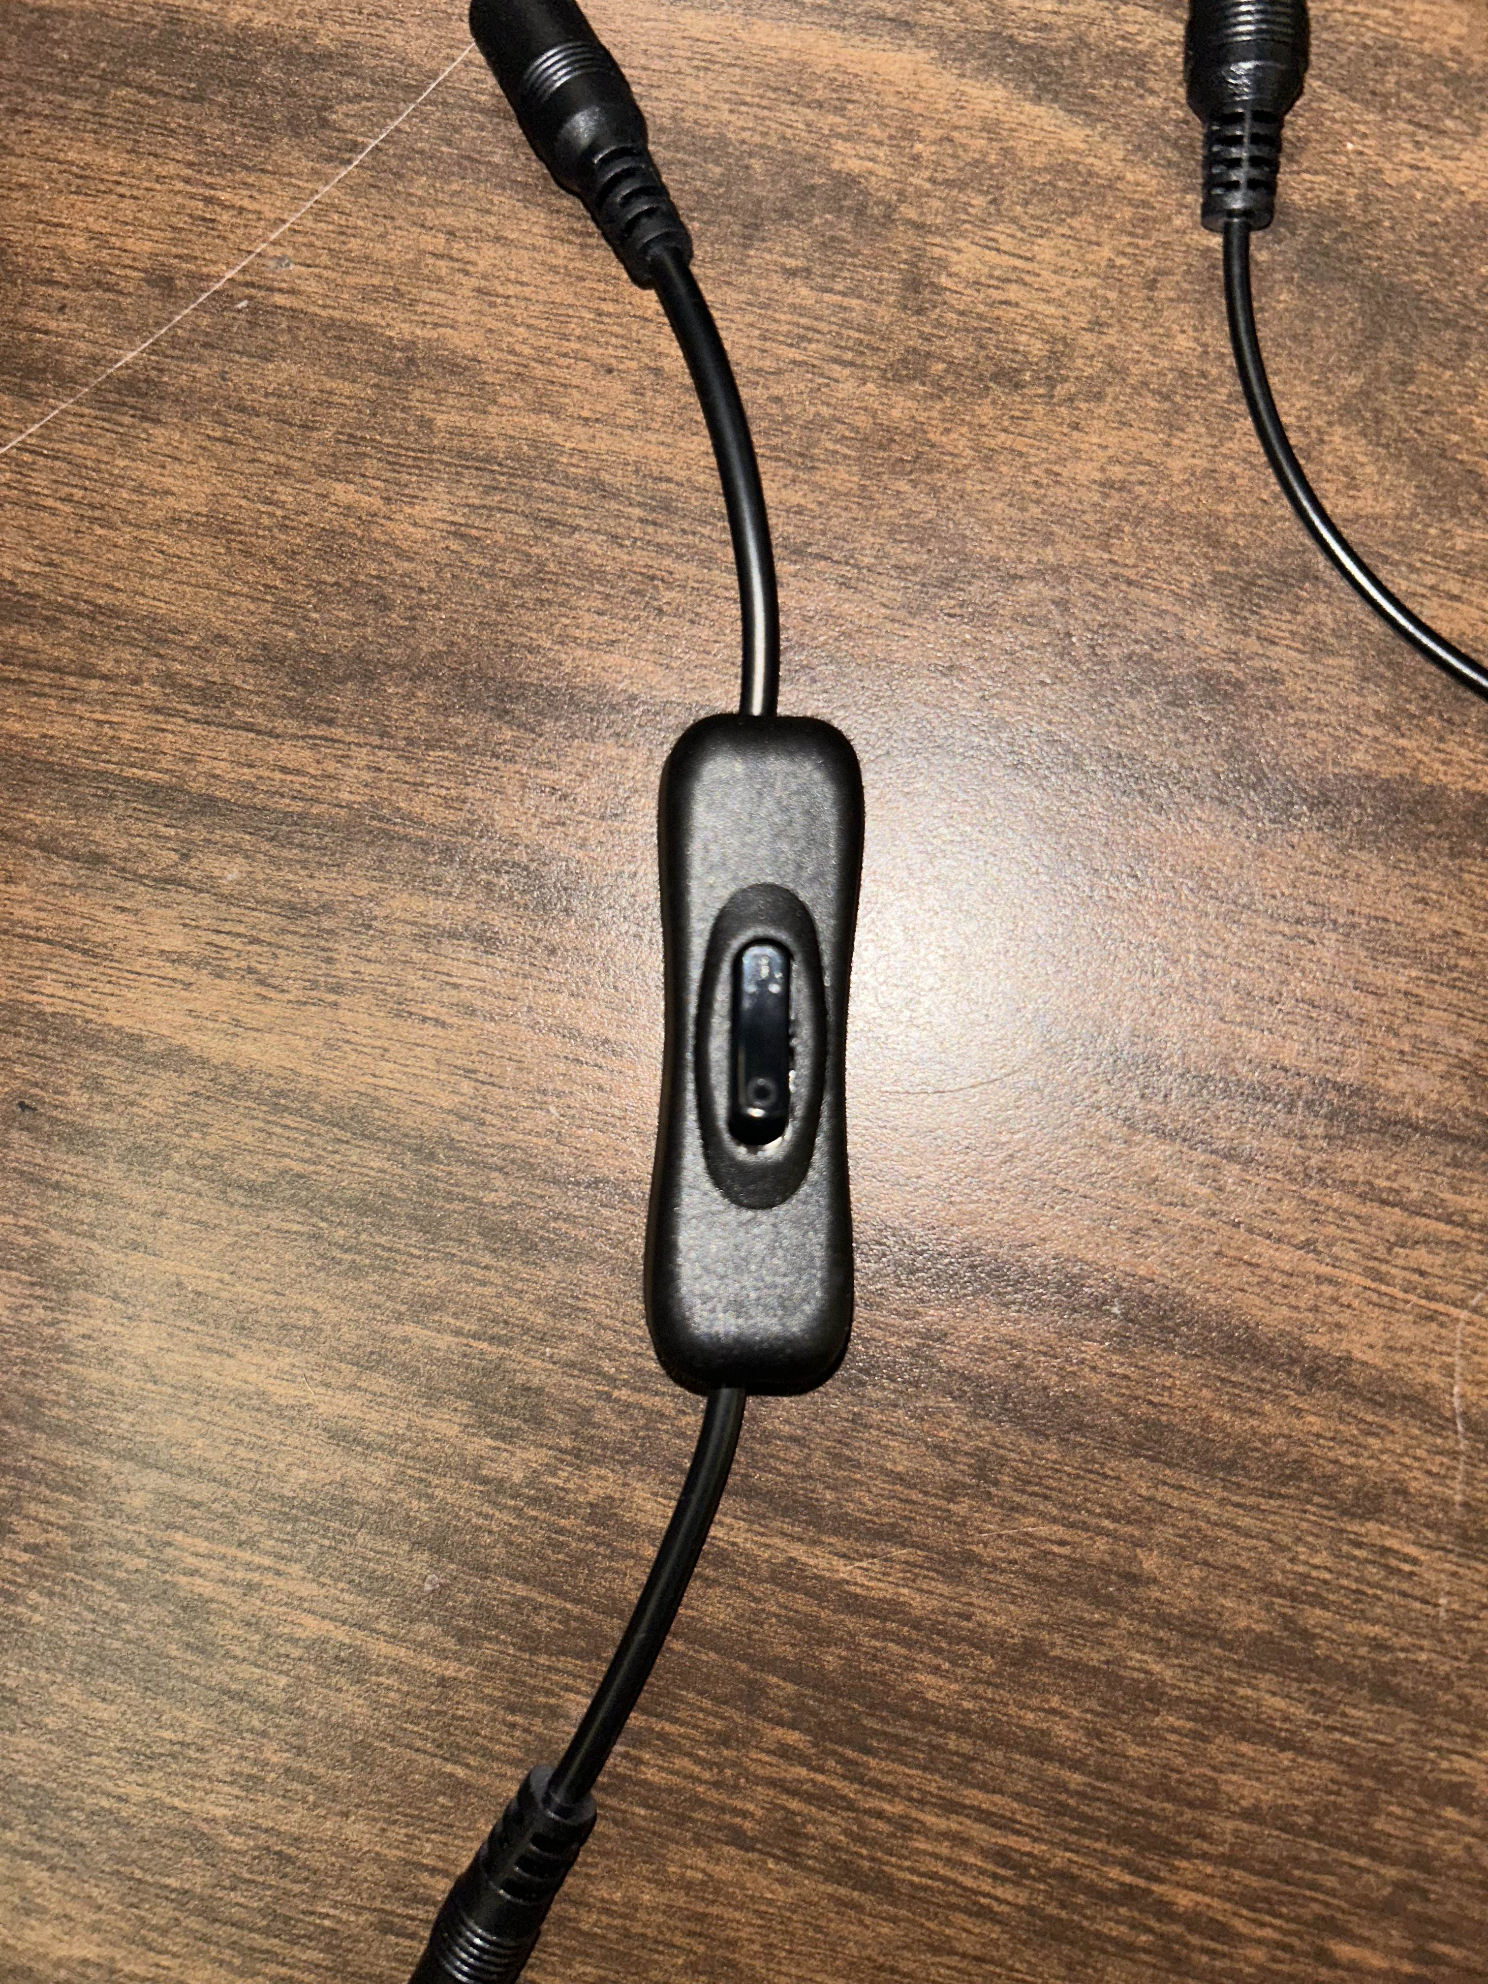

7. After you click the clips together, look for a switch like the one above, also in the trunk, and flick it on. You will know if its on or not if there is any light coming from the capsule with the boards inside

**NOTE:** to turn the firetruck OFF, follow the same steps that are declared above, but in **REVERSE**

*Created with the Personal Edition of HelpNDoc:* [*Elevate Your CHM Help Files with HelpNDoc's Advanced Customization Options*](https://www.helpndoc.com/feature-tour/create-chm-help-files/)

**How to Turn the Controller On/Off**



**Steps**:

1. First make sure that the firetruck has been turned on, as done in the previous section

2. Once you have the firetruck turned on, you are going to get your controller and turn it on by holding the both the share and the PlayStation button, visualized above

3. You are going to hold these two buttons until the controller flashes its lights and turns into a solid blue. If your controller light is a solid, stable blue, then you have paired the controller successfully and are ready to operate it. There is also no need to manually turn off the controller, once you power down the firetruck then the controller automatically turns off a couple of seconds after powering everything off.

*Created with the Personal Edition of HelpNDoc:* [*How to Protect Your PDFs with Encryption and Passwords*](https://www.helpndoc.com/step-by-step-guides/how-to-generate-an-encrypted-password-protected-pdf-document/)

**Controller Commands**



Please refer to the above visual for details regarding how to control the firetruck. Note that the water pump is activated through a toggle control, so you must click the square button once to turn it on and once to also turn it off. Lastly, for those who don't know, the button 'R3' is the button that resides within the right stick, so when you press down on the right stick, it is supposed to reset the direction of the firetruck, thus turning the wheels to be straight ahead.

*Created with the Personal Edition of HelpNDoc:* [*Free PDF documentation generator*](https://www.helpndoc.com)

**How to Fill the Water Reservior**

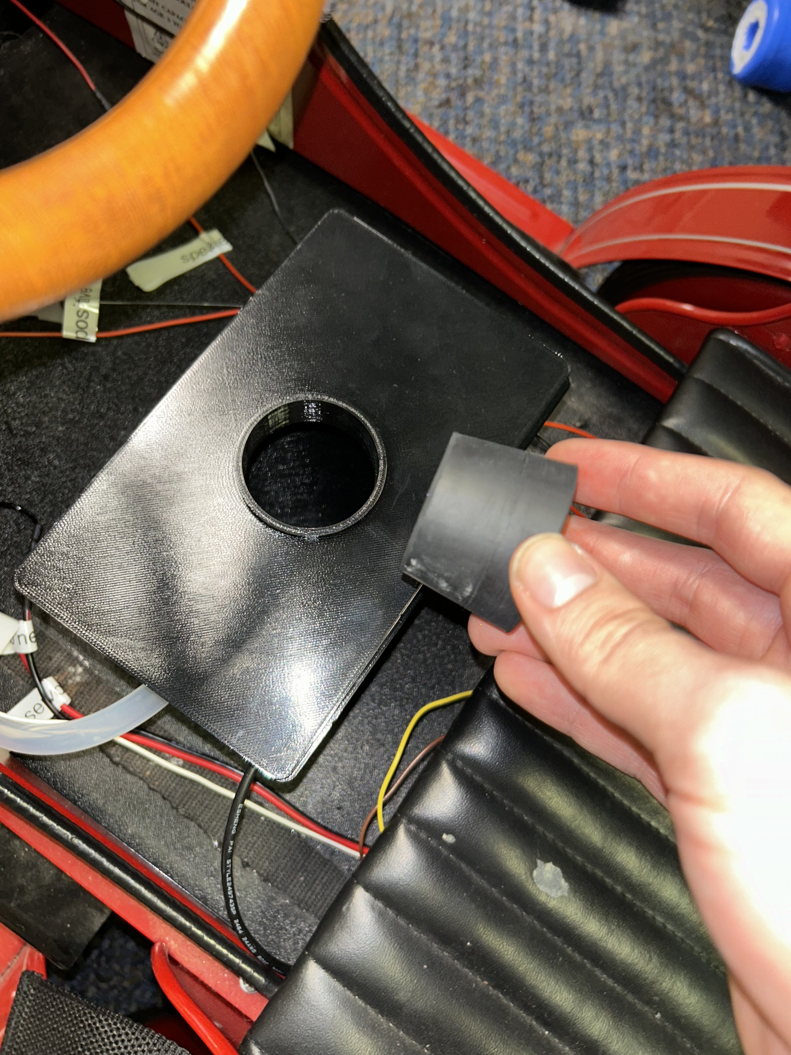

When you first recieve this firetruck, there is likely not going to be any water inside of the reservoir.

**Steps:**

1. In the middle of the firetruck, locate a black container, the reservior, such as the one pictured above. This container will be below the steering wheel of the firetruck

2. On the top of the reservior, there will be a plug like this one being held in the picture above. Remove the plug from the reservior

3. Lastly, fill the reservior with water and insert the plug back on

**NOTE:** it is better to fill the reservior while its still on the firetruck, but if you wanted to take the reservior off to fill, please remember which wire goes where when you hook everything back up

*Created with the Personal Edition of HelpNDoc:* [*Free help authoring environment*](https://www.helpndoc.com/help-authoring-tool)

**How to Charge All of the Batteries**

**NOTE: THE ARDUINO MUST BE POWERED OFF BEFORE CHARGING ANY BATTERIES (USING THE SWITCH FROM THE PREVIOUS SECTION)**

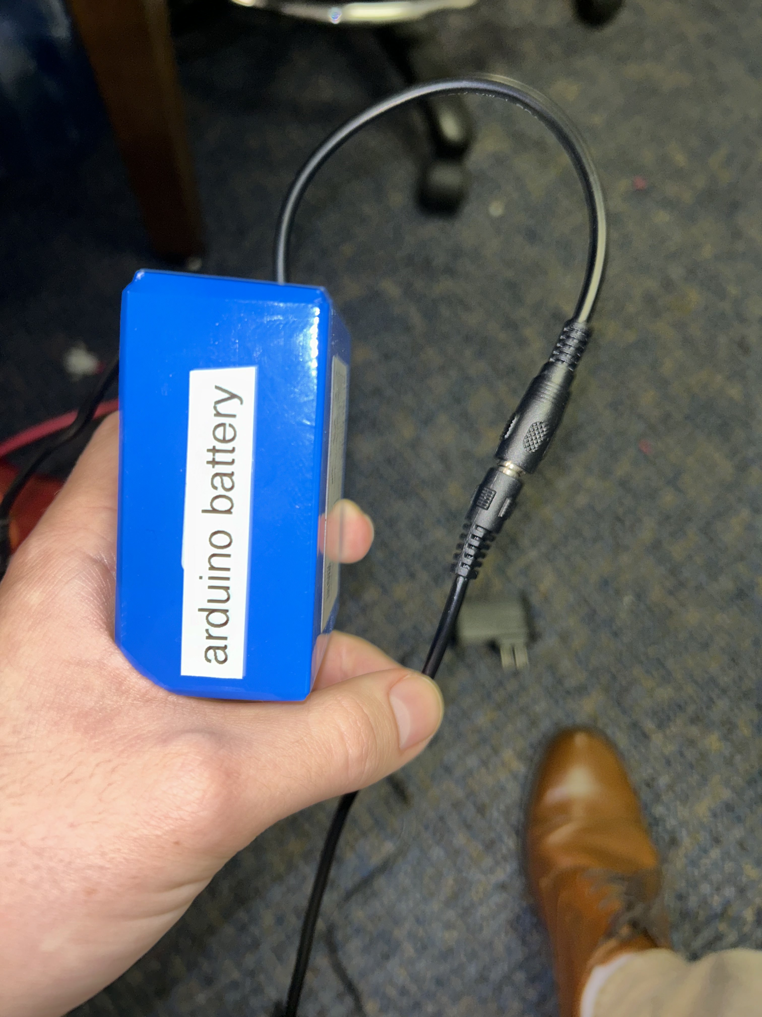

**1. Charging the Arduino Battery**

**Steps:**

1. To begin, navigate to the 'trunk' of the firetruck and take off the top cover

2. Locate the batttery labeled 'arduino battery'

3. Take the charger labled 'arduino charger' and plug it up to the barrell jack such as the visual above

4. Plug in the charger to the wall

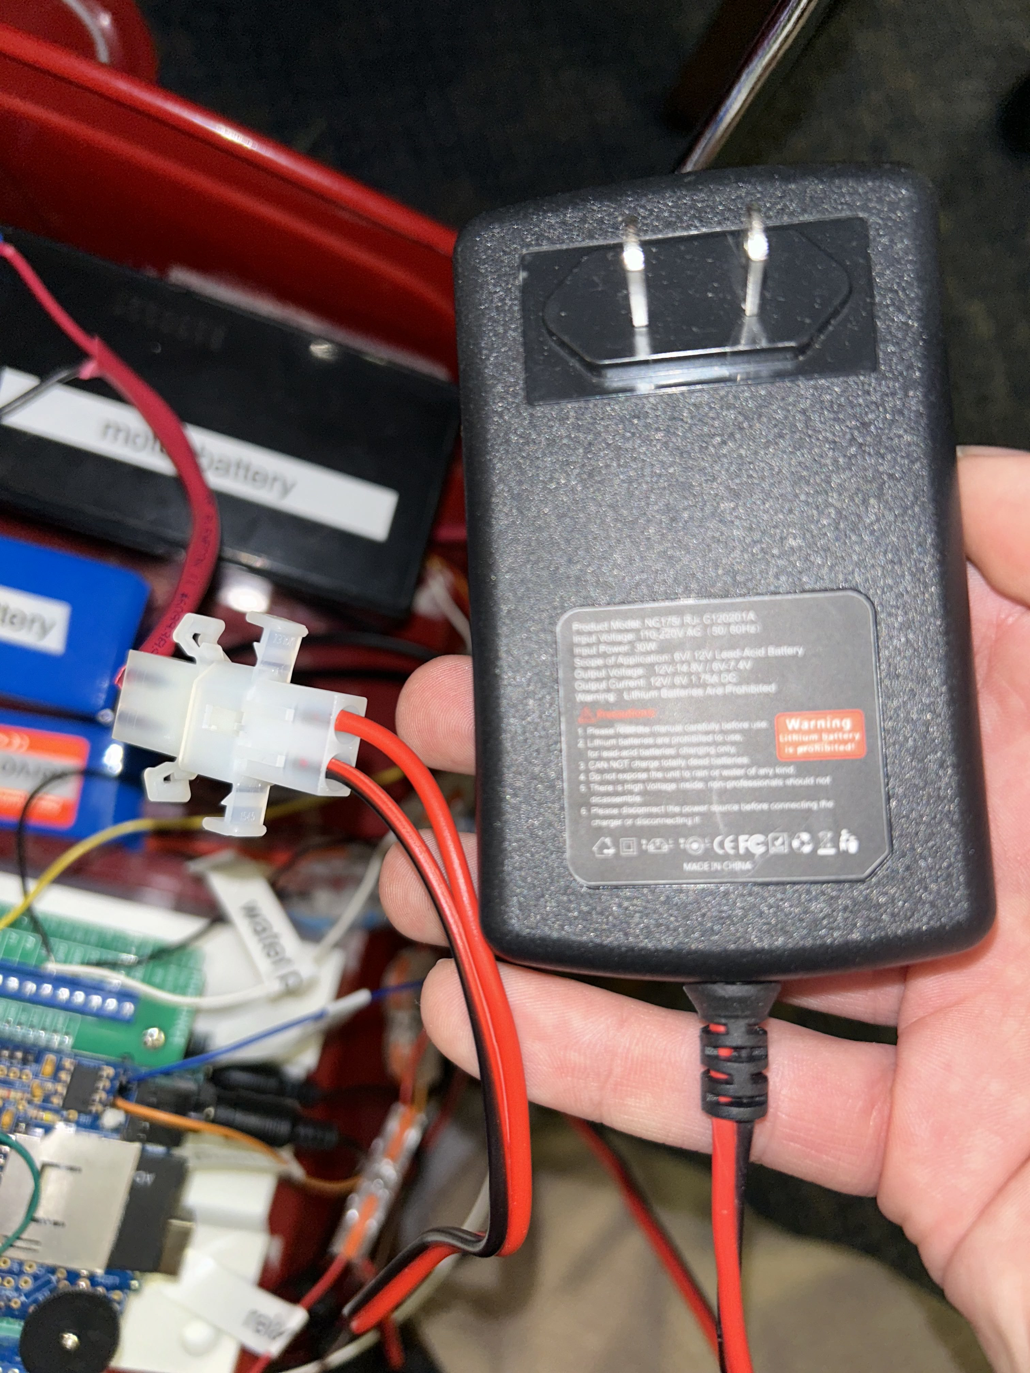

**2. Charging the Motor Battery**

**Steps:**

1. To begin, navigate to the 'trunk' of the firetruck and take off the top cover

2. Locate the battery labeled 'motor battery' in the trunk

3. Disconnect the battery from the thick red cable (depicted above)

4. Plug up your battery to the same port that you took the other cable out of (depicted above)

5. Plug in the charger to the wall

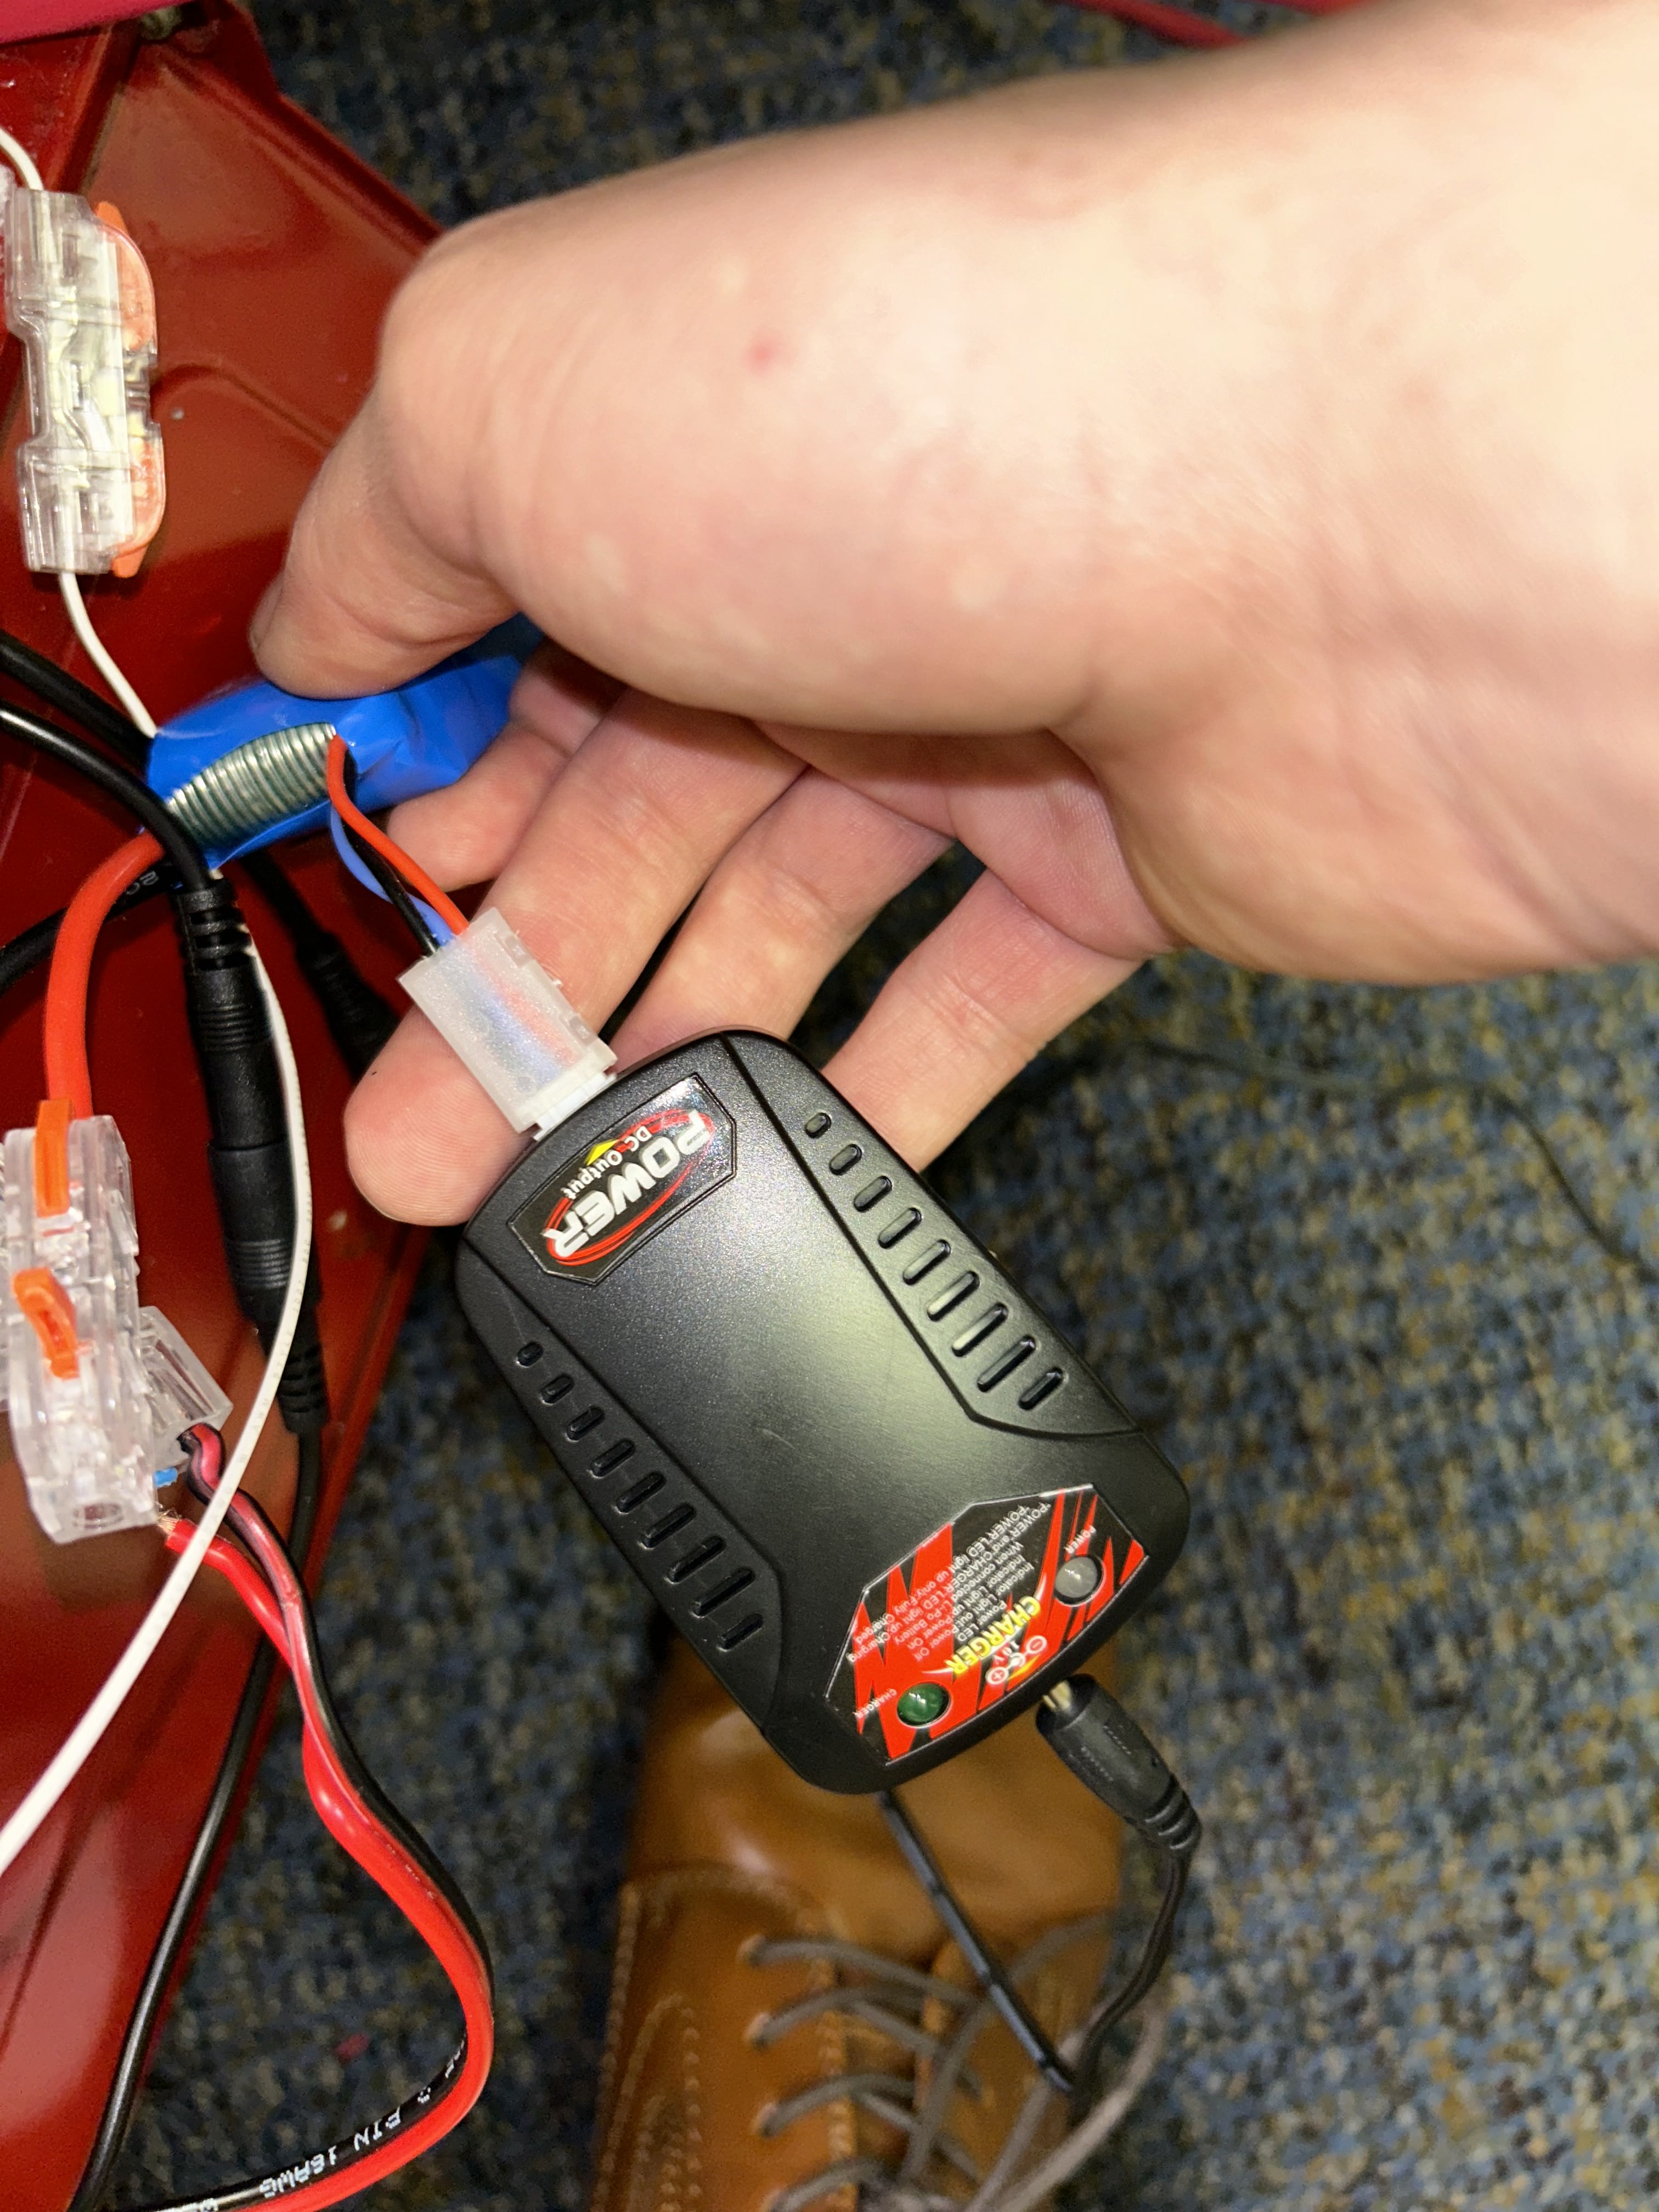

**3. Charging the Servo Battery**

**Steps:**

1. To begin, navigate to the 'trunk' of the firetruck and take off the top cover

2. Locate the battery labled 'servo battery'



3. Before proceding any further, please make sure that the red servo wire gets disconnected from the red wire of the battery by lifting up the little red tab of the plastic connector and taking the red wire out such as in the picture above

4. Once the red wire is unplugged, grab the charger that is used with the servo, shown two pictures above, and plug up the battery

**4. Charging the Controller**

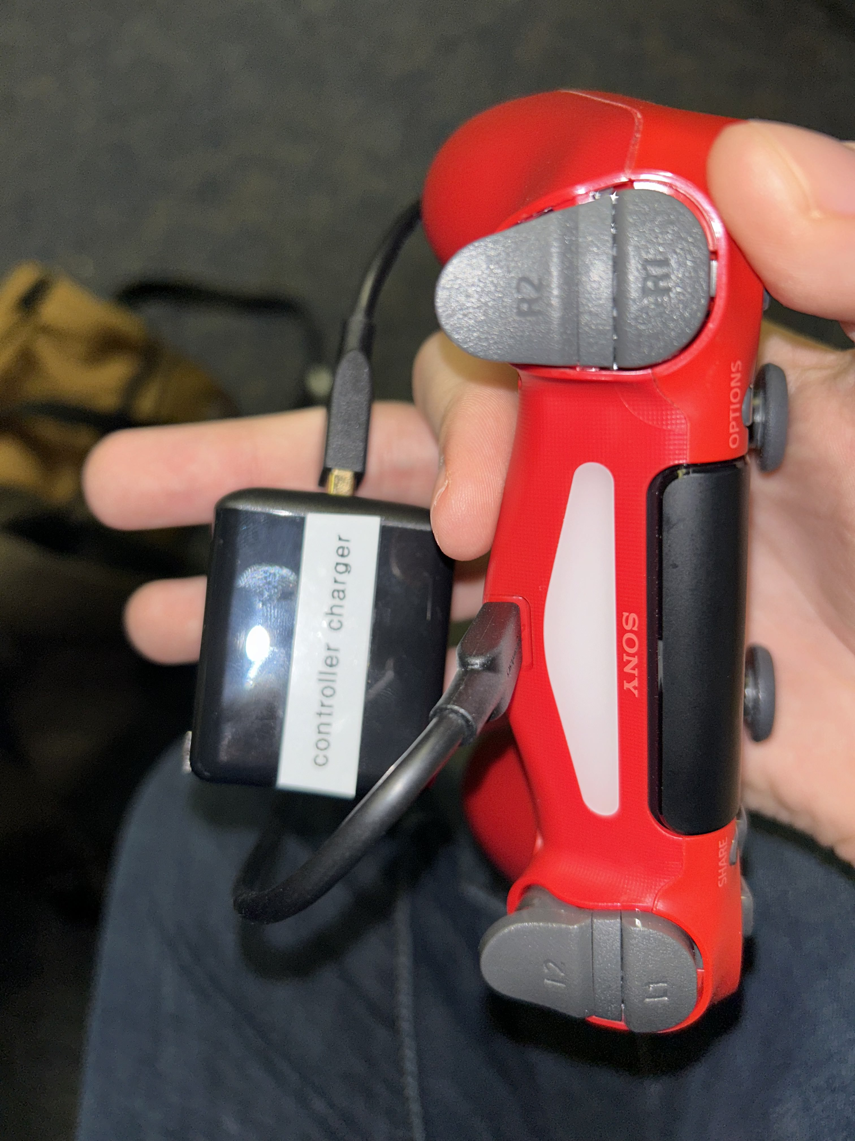

1. Locate the charger labeled 'controller charger' and plug it in to the top of the controller (a simple micro USB cable would suffice as well)

2. Plug in the charger to the wall

*Created with the Personal Edition of HelpNDoc:* [*Effortlessly optimize your documentation website for search engines*](https://www.helpndoc.com/feature-tour/produce-html-websites/)

**Quick Start Troubleshooting**

**Issue 1: Firetruck will not move**

If the firetruck is not moving then there are a couple of things that you will want to check

1. Is the Arduino turned on?



* If you do not see a green light inside of the Arduino capsule then it is likely not on. Please refer to 'How to Turn the Firetruck On/Off' for more information

2. Is the motor plugged up to the battery?



* If the motor is not plugged up like the above visual then you have not properly hooked up the motor battery. Please refer to 'How to Charge All of the Batteries' for more information

3. Is the controller turned on?

* If the controller is not lit up blue then the controller is not on. Please refer to 'How to Turn on the Controller On/Off' for more information

4. Is the motor battery charged?

* If the first three questions have been answered and the firetruck is still not moving, then the issue is likely that the battery for the motors is dead. Please refer to 'How to Charge All of the Batteries' for more information

**Issue 2: Firetruck is not steering**

If the firetruck can move but you just cannot steer, the issue then is likely to be that something is going on with the servo

1. Is the servo hooked up properly?



* If the servo is not hooked up like the photo above, then that would be your issue. Please make sure that the thick red wire is hooked up properly like above. Please refer back to 'How to Turn the Firetruck On/Off' for more information

2. Is the servo battery dead?

* If the issue is not the first one then likely the issue is that the servo battery is dead. Please refer to 'How to Charge All of the Batteries' for more information

**Issue 3: Firetruck is not shooting water when prompted to**

1. Is the reservior out of water?

* If this is the issue, then please refer back to 'How to Fill the Water Reservior' on more information on how to fix this issue

2. Is the controller turned on?

* If not, please refer to back to 'How to Turn the Controller On/Off' for more information on how to fix this issue

3. Are you clicking the right button on the controller?

* Reminder, but the pink SQUARE button toggles on/off the water pump. For more information, please refer to the 'Controller Commands' section

*Created with the Personal Edition of HelpNDoc:* [*Write EPub books for the iPad*](https://www.helpndoc.com/create-epub-ebooks)